**CS 631 DBMS**

**Final Deliverable 3**

Oun Muhammad

Nomrata Deb

Manali Khokhal

**User Guide:**

Provide admin information or Reader Card ID:

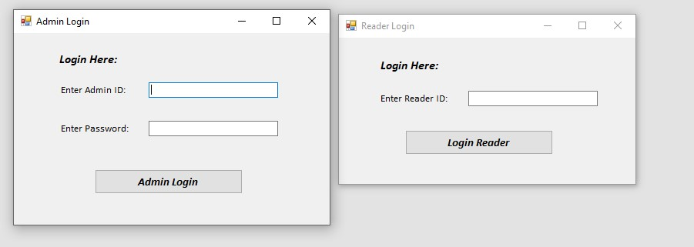

Using Reserve form reader can reserve documents

Using Check out form reader can do checkout

Using return from reader can return document

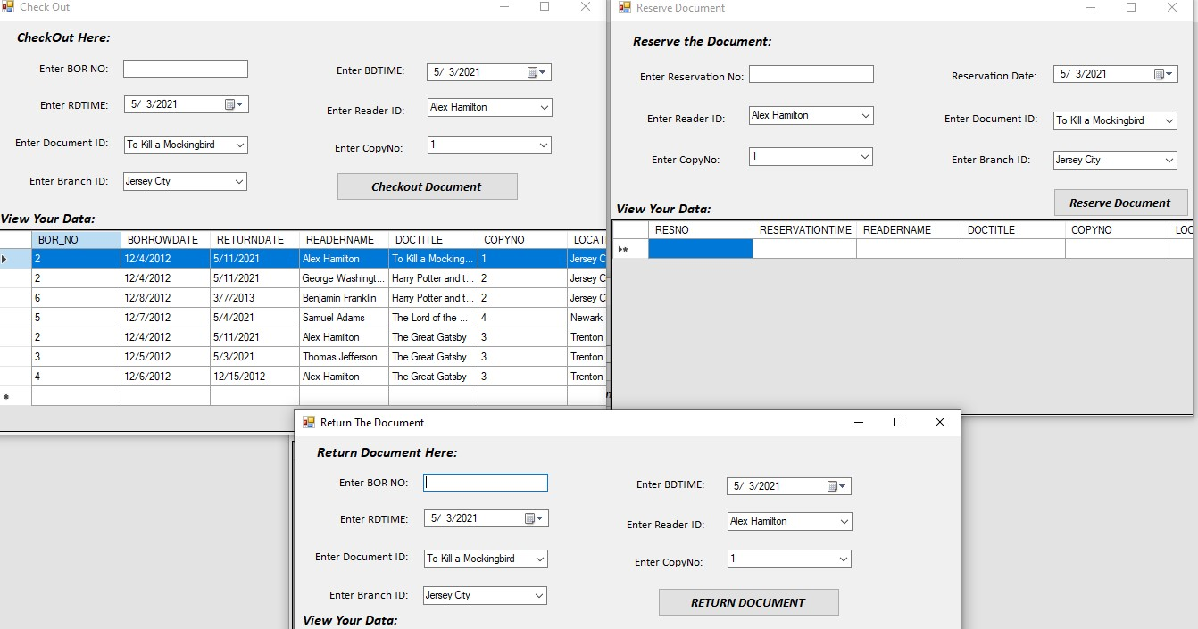

Reader can search document by ID, Title or publisher Name

Print document form reader can take out the print of list of document by publisher

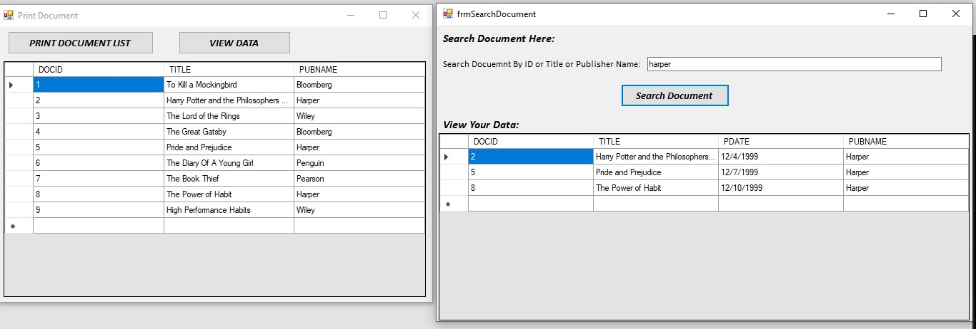

In Admin Menu, Admin can add new document and new reader

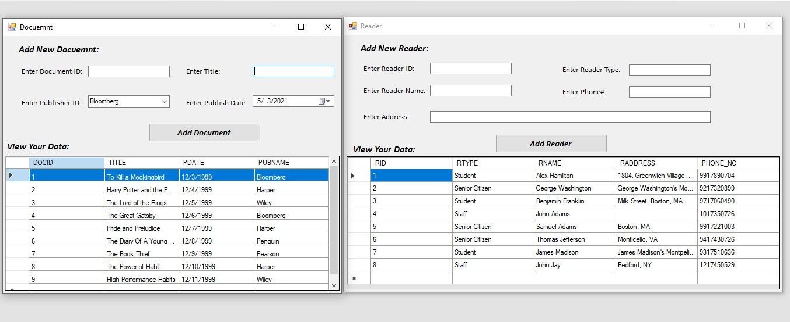

Admin can take print list of library branches

Admin can search document and its status

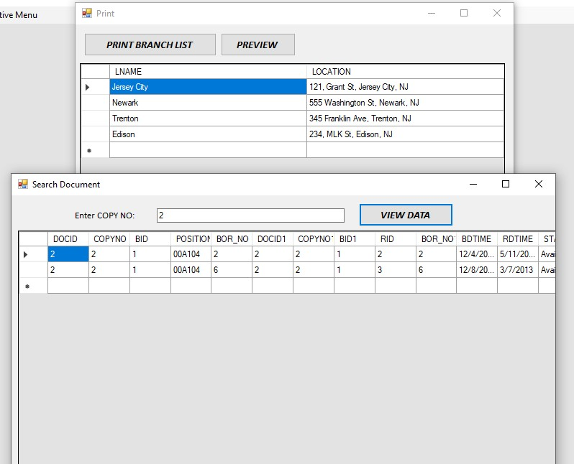

Admin can reader fine from Calculate fine form. Admin can check number of books that reader borrowed.

